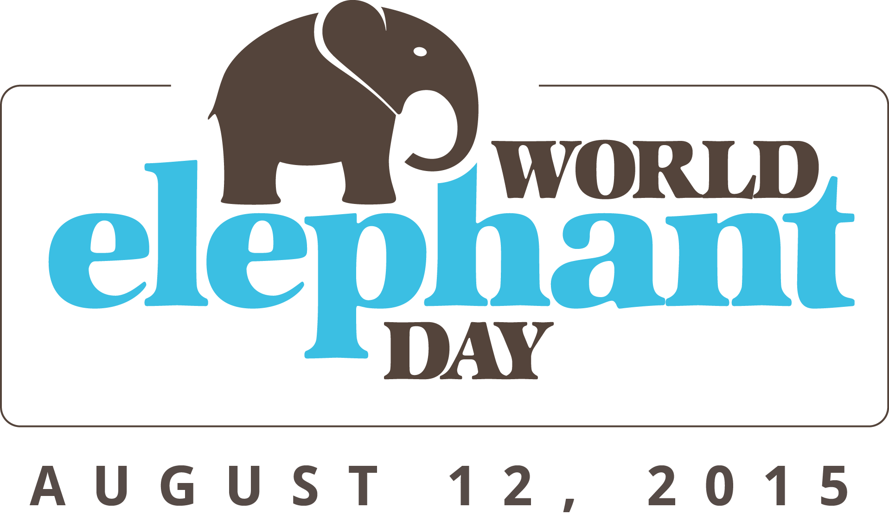

FOR IMMEDIATE RELEASE / July 28, 2015

CONTACT:
Jean Shirk, Shirk Media - jean@shirkmedia.com or 510-332-4195
Jesse Holth, World Elephant Day - jh@worldelephantday.org
Kathleen Goldstein, The Nature Conservancy - kgoldstein@greenfishcommunications.com or 202-841-0295

World Elephant Day August 12 rallies people and organizations around the world to act now to save the beloved elephant

July 28, 2015 - On Wednesday, August 12, 2015, people around the world will mark the fourth annual World Elephant Day, a day to honor elephants, to spread awareness about the violent and critical threats they are facing, and to support positive solutions that will help ensure their survival. On the day you read this, as many as 100 wild elephants will be illegally slain. Within our lifetime, elephants could face global extinction in the wild if current trends continue. World Elephant Day was launched on August 12, 2012, by Canadian documentary filmmaker Patricia Sims and the Elephant Reintroduction Foundation of Thailand. Led by Sims, World Elephant Day is now supported by over 65 wildlife organizations‪ and countless individuals in countries across the globe.

World Elephant Day supporters can take action in many ways, locally and globally, to help protect elephants from the numerous devastating impacts that threaten their survival, said Patricia Sims. “On World Elephant Day, August 12, and beyond, we encourage individuals and organizations worldwide to take action, spread awareness, and share effective ways to help save and protect elephants, and support the many commendable elephant conservation initiatives,” Sims said. World Elephant Day is a rallying call for people to support organizations that are working to stop the illegal poaching and trade of elephant ivory and other wildlife products, protect wild elephant habitat, and provide sanctuaries and alternative habitats for domesticated elephants to live freely. Learn more ways to get involved to help elephants, at http://worldelephantday.org/how-to-help-elephants.

This year, The Nature Conservancy (TNC) is an official sponsor of World Elephant Day as part of its #SaveElephants campaign. In celebration of World Elephant Day, TNC is enabling concerned individuals to help raise $150,000 for elephant conservation by simply making elephant art. For more information, visit nature.org/elegram. Dozens of other organizations around the world, large and small, including the Wildlife Conservation Society and its 96 Elephants initiative, the David Sheldrick Wildlife Trust, Bodhi Tree Foundation, S.A.F.E., and many others are launching awareness campaigns and taking action to help save elephants.

“So many people around the world love elephants but aren’t aware that elephants are in crisis. World Elephant Day helps increase security for elephants and expand habitat because it creates an opportunity to raise a rallying cry. We have to turn up the volume about the elephant crisis in order to put more pressure on leaders to take meaningful action, attract desperately needed resources, and to convince people to not buy ivory,” said Misty Herrin, #SaveElephants campaign director for The Nature Conservancy.

The survival odds for the world’s elephants are increasingly grim. Over the past decade, poaching for ivory has surged to unprecedented levels. Despite increased global awareness and dedicated efforts, a 2014 study released by Save the Elephants revealed that 100,000 African elephants were killed by poachers between 2010 and 2012 alone. According to a June 2014 report by the Convention on International Trade in Endangered Species (CITES), 20 percent of Africa’s elephants may be killed in the next ten years if poaching continues at current levels. Other research suggests that all African elephants could be extinct in the wild by 2025 if current trends continue. It is estimated that as few as 400,000 African elephants remain.

Asian elephants number fewer than 40,000 left in the world, making their official status “Endangered” on the IUCN Red List. Asian elephants face extensive loss of habitat, due to growing human populations, deforestation, and encroachment, and are also killed for their ivory, meat, and body parts, while young elephants are removed from their families and their natural environment for use in the tourism industry.

On World Elephant Day in 2014, more than 150 organizations participated worldwide, and hundreds of thousands of committed individuals took action to help elephants. Celebrities including Ricky Gervais, Betty White, Audra McDonald, Alyssa Milano, Paul McCartney, Billy Joel, Meryl Streep, and Katie Lee and wildlife conservationists including Jane Goodall took part, and New York Gov. Andrew M. Cuomo signed into law the nation’s first legislation banning the sale of ivory and rhinoceros horn on World Elephant Day. Among the partners working with Wildlife Conservation Society on the 2014 96 Elephants/World Elephant Day campaign were 56 members of the Association of Zoos and Aquariums in the US, 31 of which held onsite events to mark the day. More than 100,000 messages (drawings, letters, and petitions) were collected from supporters in 25 states for World Elephant Day, surpassing the goal of 96,000 messages to be sent to legislators in support of a national ban on the sale of ivory. #WorldElephantDay was a top-two trending hashtag on Twitter all day.

World Elephant Day co-founder Patricia Sims and co-filmmaker Michael Clark have created numerous award-winning films together, and their documentary Return to the Forest was released worldwide on the first World Elephant Day, August 12, 2012. Narrated by actor William Shatner, the film depicts the Elephant Reintroduction Foundation’s success in returning captive Asian elephants to the wild. This fall, Sims and Clark will release their new feature-length film, When Elephants Were Young, which follows the life of a young man and young elephant in Thailand, also narrated by William Shatner.

Join us on World Elephant Day August 12 and afterwards, to celebrate our elephant friends and to do what you can to help ensure their survival.

Get involved with World Elephant Day on social media:
- Follow World Elephant Day on Facebook: http://www.facebook.com/worldelephantday
- Follow World Elephant Day on Twitter: http://twitter.com/wrldelephantday
- Follow World Elephant Day on Instagram: http://instagram.com/worldelephantday
- Share a World Elephant Day banner on your Facebook page
- Tweet your support of elephants with our tailored tweets leading up to and on World Elephant Day
- Check out the World Elephant Day site for social media tools and more ideas
- Use #WorldElephantDay hashtags: #WorldElephantDay #GoGrey #BeHerd #Elegram #SaveElephants #SayNoToIvory

